GARI Advanced Search - Instructions

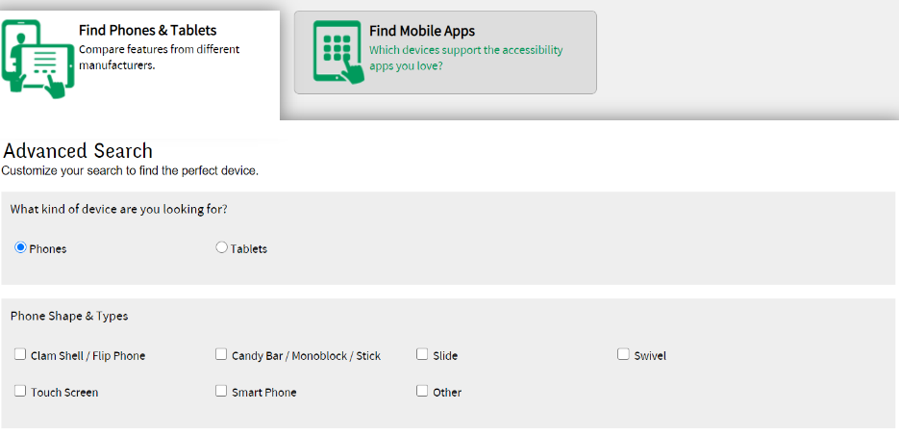

Step 1:
Select “Phone” where you are asked “What kind of device are you looking for?”

Under “Phone Shapes & Types”, select which style of shape you would like to include in your search. If you don’t have a preference you can skip this option.

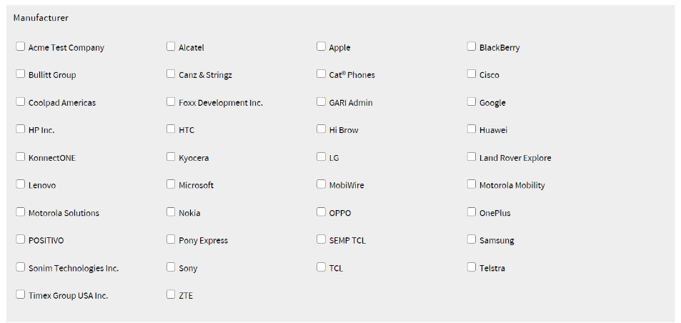

Step 2:
Under “Manufacturer”, select the manufacturers you would like information for by clicking on the box next to their name. Use this option if you want to narrow your search to only a few manufacturers. If you don’t have a preference you can skip this option.

Under “Region”, select North America to ensure that you are choosing from phones that are available.

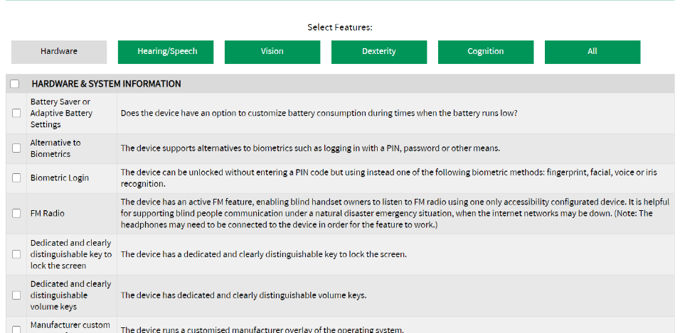

Step 3:
If you know what features you would like to include in your search you can pick them by clicking in the box beside them. You can pick from Hardware & System Information, for based on features relevant for various disabilities.
Scroll down the page and click “Search Now” to get results.

